Hand in 6
By Eirik Storrud Røsvik
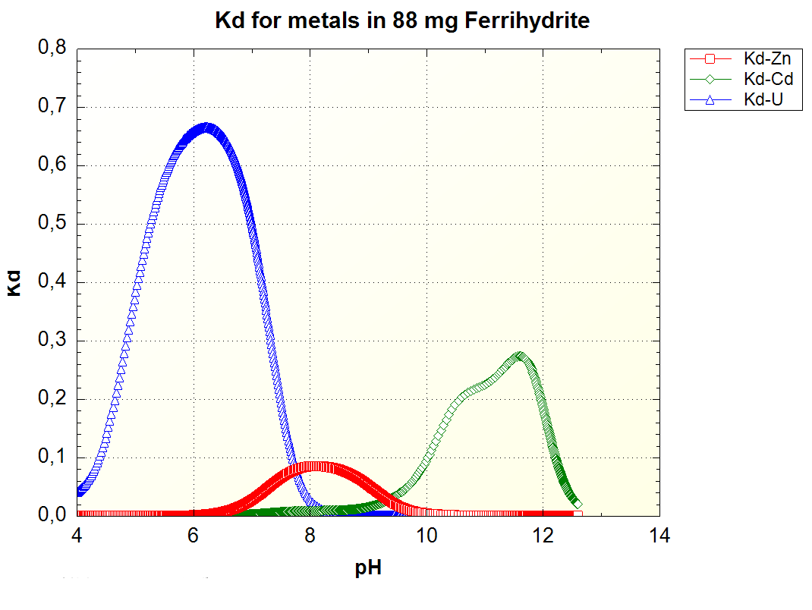
In this graph, higher values constitutes more sorbed amount. For Kd = 1, all the particles are sorbed, while for Kd = 0, all the particles are in solution. Kd can be converted to percentage sorbed by simply multiplying by 100.
By the graph, it can be seen that for low pH values (pH < 6) only Uranium is sorbed to the ferrihydrite particles. From a pH of around 6 the amount of uranium starts to plateau, the uranium then rapidly decreases shortly after reaching its highest distribution coefficient of 0.665 at pH 6.2. At pH 8.2 the distribution coefficient of uranium is less than 0.01.
At around pH 6, Zinc starts to get sorbed, reaching Kd = 0.01 at pH = 5.89. The amount of Zink sorbed reaches its peak at the same time as almost all the Uranium is back in solution at pH = 8.1. Zinc reaches a peak Kd of 0.0854. The amount of sorbed Zinc decreases from this point and reaches a Kd of 0.01 at pH = 9.7.
Cadmium is the last metal to start getting sorbed, reaching a Kd of 0.01 at pH 8.45, shortly after zinc starts getting reabsorbed into solution. Cadmium reaches a Kd of 0.099 at pH 10, but this is only the beginning of its curve, as the pH increases above 10, cadmium would continue to get sorbed up to pH = 11.5, where the Kd of cadmium would have been 0.273. Above pH 10, cadmium shows a curve more complex than can be observed in uranium and zinc who both follows a quadratic curve. This could be due to another metal being sorbed and reabsorbed into solution at the same pH values as cadmium, but being reabsorbed at slightly lower pH values, thus freeing the ferrihydrite for the cadmium ions.

